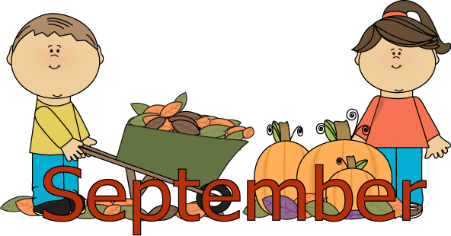

**Third Grade News and Announcements**

**Welcome to 3rd grade students and families!**

[**zabboj@foxborough.k12.ma.us**](mailto:zabboj@foxborough.k12.ma.us)

**508-543-1607 voicemail 77321**

**Third grade is an incredible year. Our overall focus is on building independence and accountability. As the school year begins we are setting up routines and listing expectations. Our expectations are high and we are confident your children will work rigorously to achieve the most from third grade.**

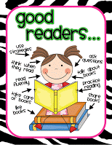 **Reading and Writing Workshop**

During the month of September we will be launching the reading workshop model in our classroom. Students will be practicing routines, procedures and expectations for a successful workshop model. These first few weeks we will be focusing on good independent reading practices, such as building stamina children need to read for longer periods of time, selecting just right books, recording our thinking while reading, sharing our thinking with each other, abandoning a book, writing response journals, book recommendations, and solving unknown words. I will be conducting DRA reading assessments to find each student’s independent and instructional reading levels. I will form my guided reading groups based on student’s instructional levels. Students will also focus on two comprehension strategies activating schema (background knowledge) and making connections to text. We encourage a continued practice of their reading habits at school and at home with you. Please allow them to read every day for 20-30 minutes and ask students to tell you what they learned or what the main idea is.

[https://tse1.mm.bing.net/th?&id=OIP.Ma977b7d5b2c95604097075d5a36c4bcfo0&w=392&h=57&c=0&pid=1.9&rs=0&p=0&r=0](https://www.bing.com/images/search?q=writing+workshop&view=detailv2&&id=A416AB4074520871FEAC172729C15B0DD8FBF910&selectedIndex=68&ccid=qXe31bLJ&simid=607990731136305163&thid=OIP.Ma977b7d5b2c95604097075d5a36c4bcfo0)

This school year students will have a writer’s notebook. We will be learning how writers use their notebooks to record their thoughts about their worlds. We will be collecting and exploring ideas by writing, sketching, and gluing in artifacts. Students will learn how to draft a paper, organize revise, edit, conference, and publish their writing. We will begin to explore narrative writing and focus on creating a story based on a small moment of time.

We will have a separate poetry journal where students will practice reading poems for fluency, learn about literacy and poetic devices, identify and understand unknown words, and interpret the meaning of the poems.

Our class will be using a word wall this year. Each month students will be practicing high frequency words, (words that appear most in print) these words are also the most frequently misspelled words. Once these words go up on the word wall students are expected to spell them correctly in their everyday writing. September’s words are: ***again, into, off, because, people, could, said, they, could, favorite, until, very, have, want, who***.

At home try:

* **Carefully select "Just Right" books to read during nightly reading. By talking about your past adventures as a family it will help your child think of ideas to write about during our Narrative writing unit. Practice the monthly words in creative ways; using play dough, flash cards, car travel quizzes or through magnet letters.**

**Math**

During the month of September students will be reviewing addition and subtraction math facts and beginning to learn multiplication math facts strategies for ( 0,1). Students will be using the Think Math series and exploring Chapter 1 place value and Chapter 3 addition and subtraction, as well as an introduction to rounding and estimating to nearest 10 and 100. Please see attached sheet about our current math units.

At home try:

* **Practice math fact fluency each night using facts cards, Ipad apps, websites, and/ or the weekly math games.**

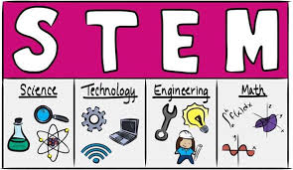

**STEM** is an exciting approach to teaching that stimulates children’s creativity and draws upon their natural curiosity. This term students will plan, create, test and ask questions focused around real world challenges. Students will be faced with challenges and have to work together to problem solve. Examples of these students will participate in are as follows.

**Bridge the Gap** Students must design and build a bridge that can support the weight of four people.

**Well Rescue** Students must design and build a device that can pick up a toy bear from the bottom of the well.

**Flash Flood** Students must design and build a dam that will stop a flood of water.

**Social Studies**

Students will be learning about Massachusetts, the New England States, and geography skills, such as compass rose, map key, map symbols.

At home try:

**While driving in the car ask your child to follow along with your journey using a map of the area. Encourage your child to create an emergency map for your home.** Check out the book Nicholas: A Massachusetts Tale which is about a mouse named Nicholas and journey across the state of Massachusetts.

**Technology**

This month we are learning how to use basic computer hardware and applications, such as selecting a printer, printing a document, and using Microsoft word. Our class has begun to type Acrostic Name Poems and will be learning how to format the text, insert a picture or clipart, and print. There is a great website that introduces keyboarding skills and proper keyboarding techniques. I encourage you to give your child time at home to work on this. Check it out when you have some free time:[www.bbc.co.uk/schools/typing](http://www.bbc.co.uk/schools/typing)

Our class will be having an online blog. More info. to follow!

At home:

Your child can practice the skills they are learning in school.

**Cursive**

This month students will be learning cursive i, t, u, and w. Please see attached sheets that show proper letter formation. Students are encouraged to practice the letters taught in school at home. Please remind your child that cursive is like art, when we are learning the letter formation slow and steady are the best strategies. Also correct body posture and paper tilt are key.

At home try:

* **Using a white board, pencil and paper, or shaving cream practice the weekly letters. Remind your child that cursive is like art, when we are learning the letter formation slow and steady are the best strategies. Also correct body posture and paper tilt are key.**

**Science**

This month students will begin a unit on Life Cycles. Students will build a basic knowledge about living organisms, life cycles, and their stages, the process of metamorphosis, and extinction of species. Throughout the unit students will make observations and drawings in their Science Notebook as they observe the lifecycles of animals and plants.